**CHAPTER-4 Class Room Objective**

**CLASSIFICATION/ ODD ONE OUT**

**Directions: From the given responses, find the odd figure out.**

**Q1**. Question figure

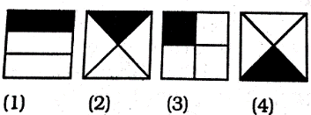

**Q2.** Question figure

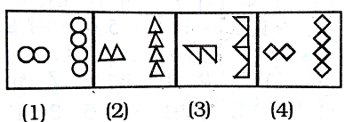

**Q3.**Question figure

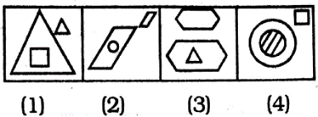

**Q4**. Question figure

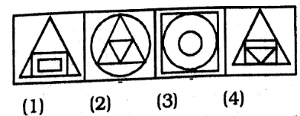

**Q5. Question figure**

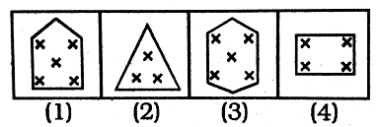

**Q6. Question figure**

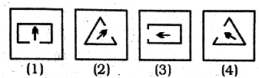

**Q7. Question figure**

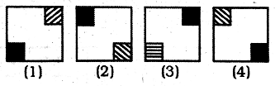

**Q8. Question figure**

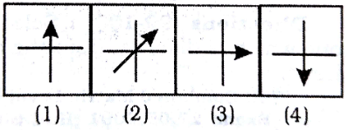

**Q9.** Question figure

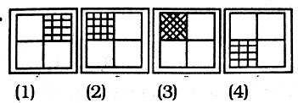

**Q10. Question figure**

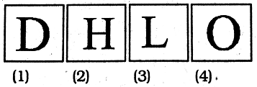

**Q11.** Question figure

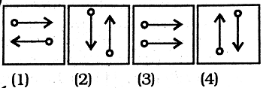

**Q12**. Question figure

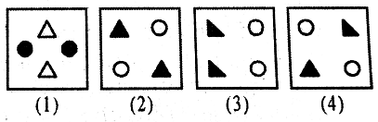

**Q13**. Question figure

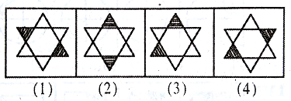

**Q14**. Question figure

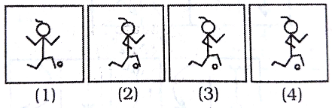

**Q15. Question figure**

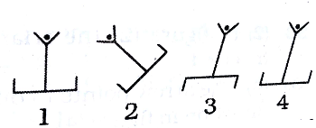

**Q16. Question figure**



**Q17. Question figure**

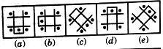

**Q18. Question figure**



**Q19. Question figure**

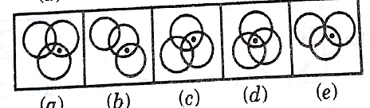

**Q20.** Question figure

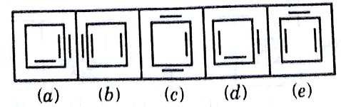

**Q21.** Question figure

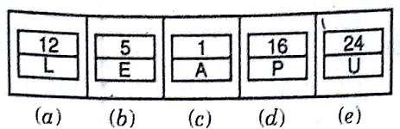

**Q22. Question figure**

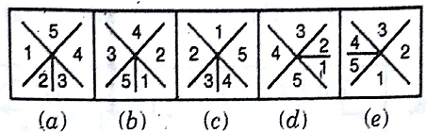

**Q23. Question figure**

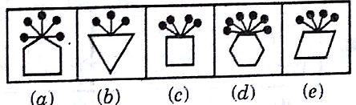

**Q24.** Question figure

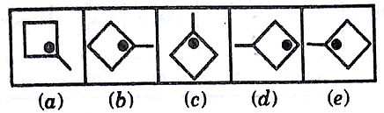

**Q25. Question figure**

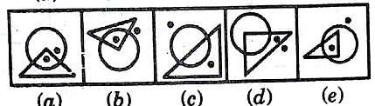

**Q26. Question figure**

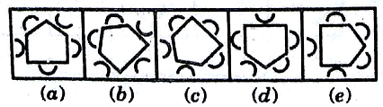

**Q27. Question figure**

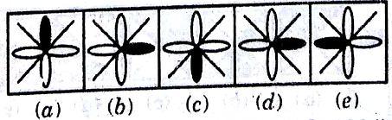

**Q28. Question figure**

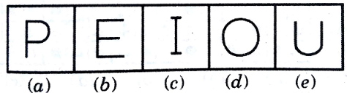

**Q29. Question figure**

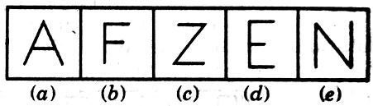

**Q30. Question figure**

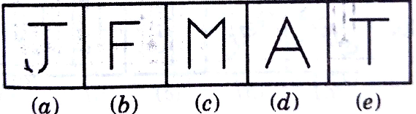

ANSWERS

|  |  |  |  |  |
| --- | --- | --- | --- | --- |
| **1.(a)** | **2.(c)** | **3.(d)** | **4(d)** | **5.(c)** |
| **6(a)** | **7(c)** | **8(b)** | **9(c)** | **10.(d)** |
| **11.(c)** | **12.(d)** | **13.(c)** | **14.(a)** | **15.(c)** |
| **16.(c)** | **17.(c)** | **18.(b)** | **19.(d)** | **20.(c)** |
| **21.(e)** | **22.(b)** | **23.(a)** | **24.(d)** | **25.(a)** |
| **26.(b)** | **27.(b)** | **28.(a)** | **29.(d)** | **30.(e)** |

*************************